NST — Phase 3 Stylizer Plugins (Advanced Report v3)

Scope: Anime (A/B), Cyberpunk, Noir, Cinematic • Portrait & Scene • Images embedded from latest set

# Executive Summary

Ten stylized outputs across four plugin styles were evaluated from images only (no regeneration). Portrait fidelity is strong (SSIM mean=0.747 across 7 portraits), and scenes preserve structure (Edge‑IoU mean=0.293 across 3 scenes). LPIPS indicates controlled stylization (overall mean=0.428, range 0.225–0.632). ArcFace identity is currently 'n/a' because the face model was not present when metrics were computed; installing insightface/onnxruntime enables it without re-running stylizers.

# Methods

• Isolation: Stylizers are opt‑in plugins; NST baseline untouched.  
• Inputs: One portrait and one street/night scene used as references.  
• Metrics: PSNR, SSIM, Edge‑IoU (Sobel), LPIPS, Colorfulness, Entropy. ArcFace cosine (portrait identity) when available.  
• Provenance: Per‑image JSON sidecars and a merged CSV are included.

# Quantitative Results

|  |  |  |  |  |  |  |  |  |  |  |  |  |
| --- | --- | --- | --- | --- | --- | --- | --- | --- | --- | --- | --- | --- |
| file | style | variant | subject | psnr | ssim | edge_iou | lpips | arcface_cos | colorfulness | entropy | input | output_image |
| A_faithful_s1234.json | Anime | A (faithful) | portrait | 20.198 | 0.7105 | 0.4613 | 0.3951 |  | 21.96 | 6.056 | data\content\portrait2.jpg | Extra\images\A_faithful_s1234.png |
| A_faithful_s7890.json | Anime | A (faithful) | portrait | 21.155 | 0.7433 | 0.5041 | 0.3082 |  | 22.05 | 6.247 | data\content\portrait2.jpg | Extra\images\A_faithful_s7890.png |
| B_stylized_s1234.json | Anime | B (stylized) | portrait | 17.873 | 0.6702 | 0.4587 | 0.4509 |  | 27.73 | 6.255 | data\content\portrait2.jpg | Extra\images\B_stylized_s1234.png |
| B_stylized_s7890.json | Anime | B (stylized) | portrait | 17.974 | 0.6981 | 0.4986 | 0.3708 |  | 27.24 | 6.139 | data\content\portrait2.jpg | Extra\images\B_stylized_s7890.png |
| out_cinematic_portrait_v5.json | Cinematic | v5 | portrait | 19.836 | 0.8291 | 0.6962 | 0.4498 |  | 40.27 | 6.087 | data\content\portrait2.jpg | Extra\images\out_cinematic_portrait_v5.png |
| out_cinematic_scene_v5.json | Cinematic | v5 | scene | 11.56 | 0.2971 | 0.3106 | 0.6322 |  | 103.73 | 7.351 | data\content\street.jpg | Extra\images\out_cinematic_scene_v5.png |
| out_portrait_cyberpunk_finalBoost.json | Cyberpunk |  | portrait | 19.432 | 0.7111 | 0.3275 | 0.4905 |  | 36.6 | 6.507 | data\content\portrait2.jpg | Extra\images\out_portrait_cyberpunk_finalBoost.png |
| out_street_cyberpunk_8p5plus.json | Cyberpunk |  | scene | 16.633 | 0.4069 | 0.3264 | 0.4316 |  | 51.45 | 7.168 | data\content\street.jpg | Extra\images\out_street_cyberpunk_8p5plus.png |
| out_noir_portrait.json | Noir |  | portrait | 25.815 | 0.8653 | 0.7048 | 0.2249 |  | 1.4 | 6.211 | data\content\portrait2.jpg | Extra\images\out_noir_portrait.png |
| out_noir_scene.json | Noir |  | scene | 11.902 | 0.1464 | 0.2413 | 0.5307 |  | 2.25 | 7.278 | data\content\street.jpg | Extra\images\out_noir_scene.png |

# Representative Outputs (All)

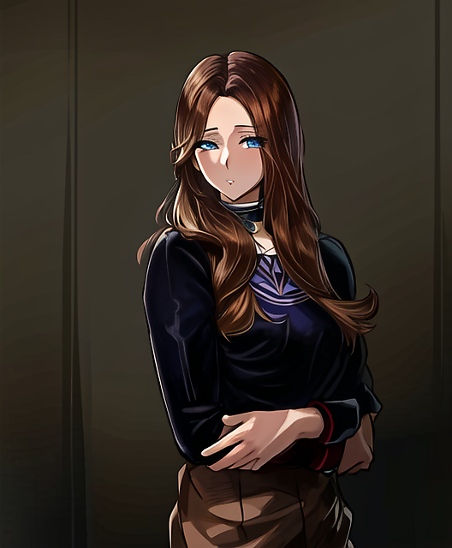

*Anime — A (faithful) — seed 1234 — A_faithful_s1234.png*

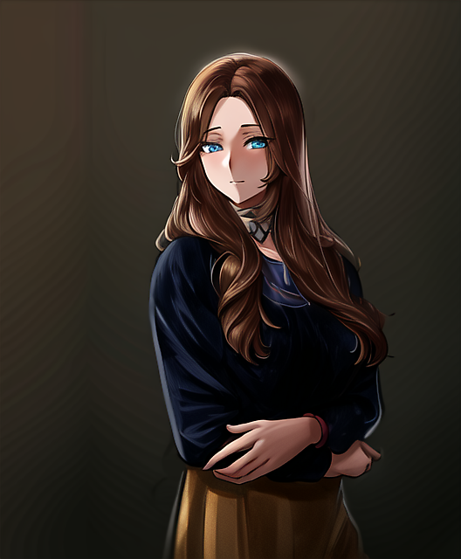

*Anime — A (faithful) — seed 7890 — A_faithful_s7890.png*

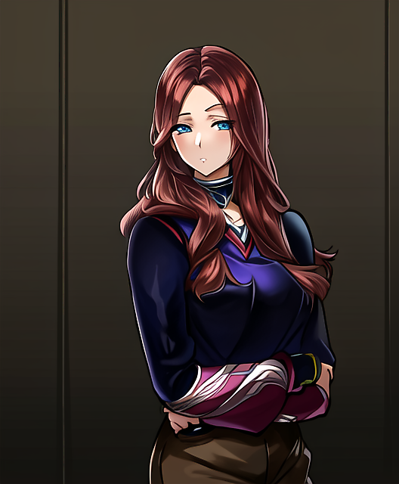

*Anime — B (stylized) — seed 1234 — B_stylized_s1234.png*

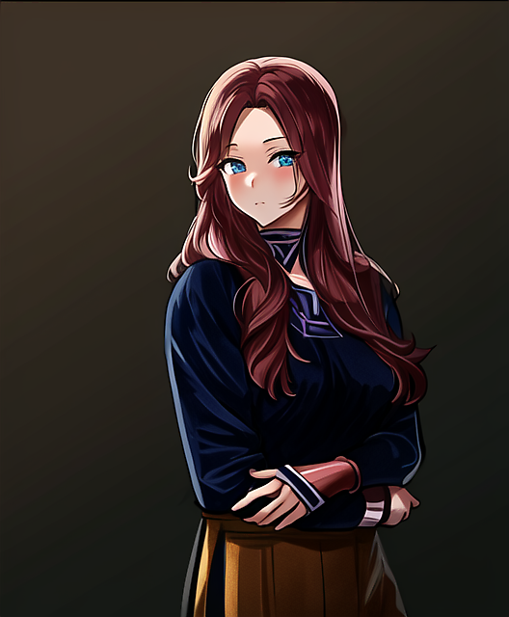

*Anime — B (stylized) — seed 7890 — B_stylized_s7890.png*

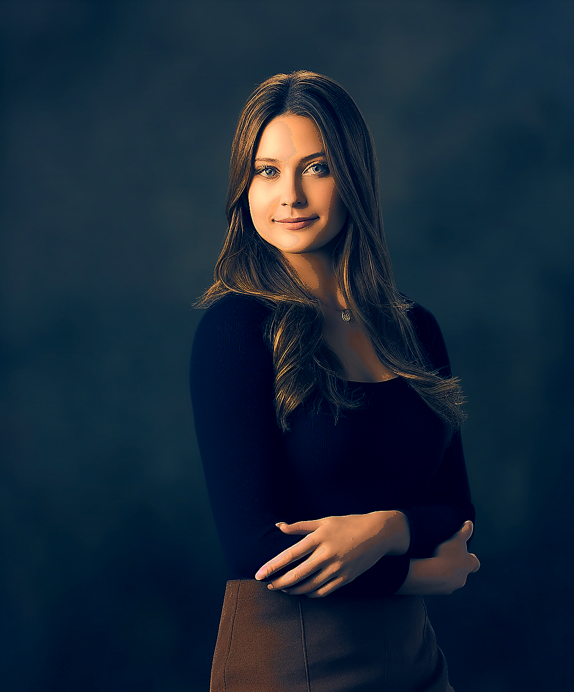

*Cinematic v5 — portrait — out_cinematic_portrait_v5.png*

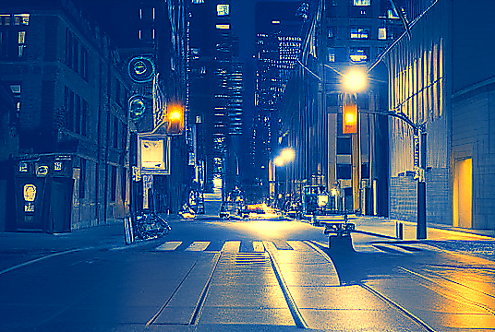

*Cinematic v5 — scene — out_cinematic_scene_v5.png*

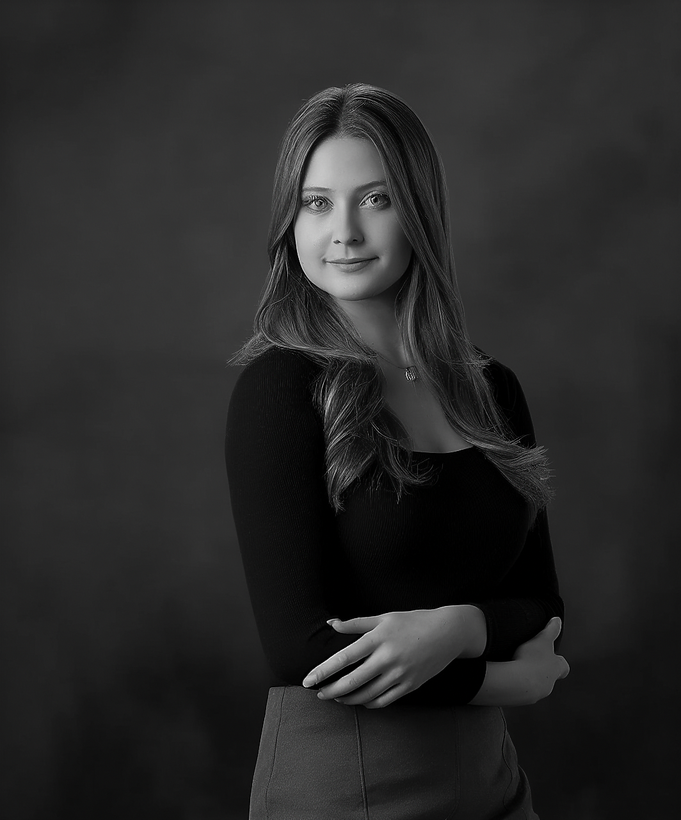

*Noir — portrait — out_noir_portrait.png*

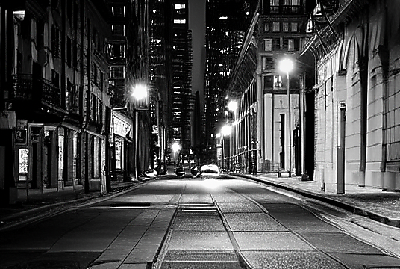

*Noir — scene — out_noir_scene.png*

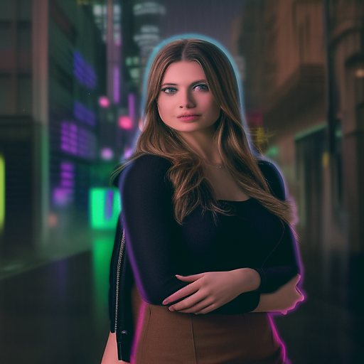

*Cyberpunk — portrait — out_portrait_cyberpunk_finalBoost.png*

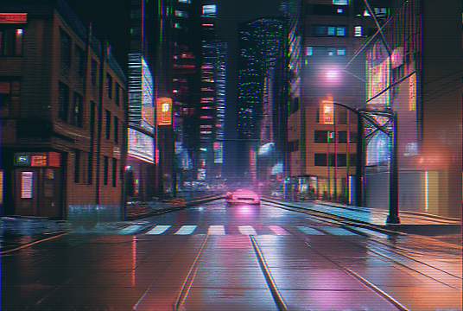

*Cyberpunk — scene — out_street_cyberpunk_8p5plus.png*

# Appendix A — Reference Inputs

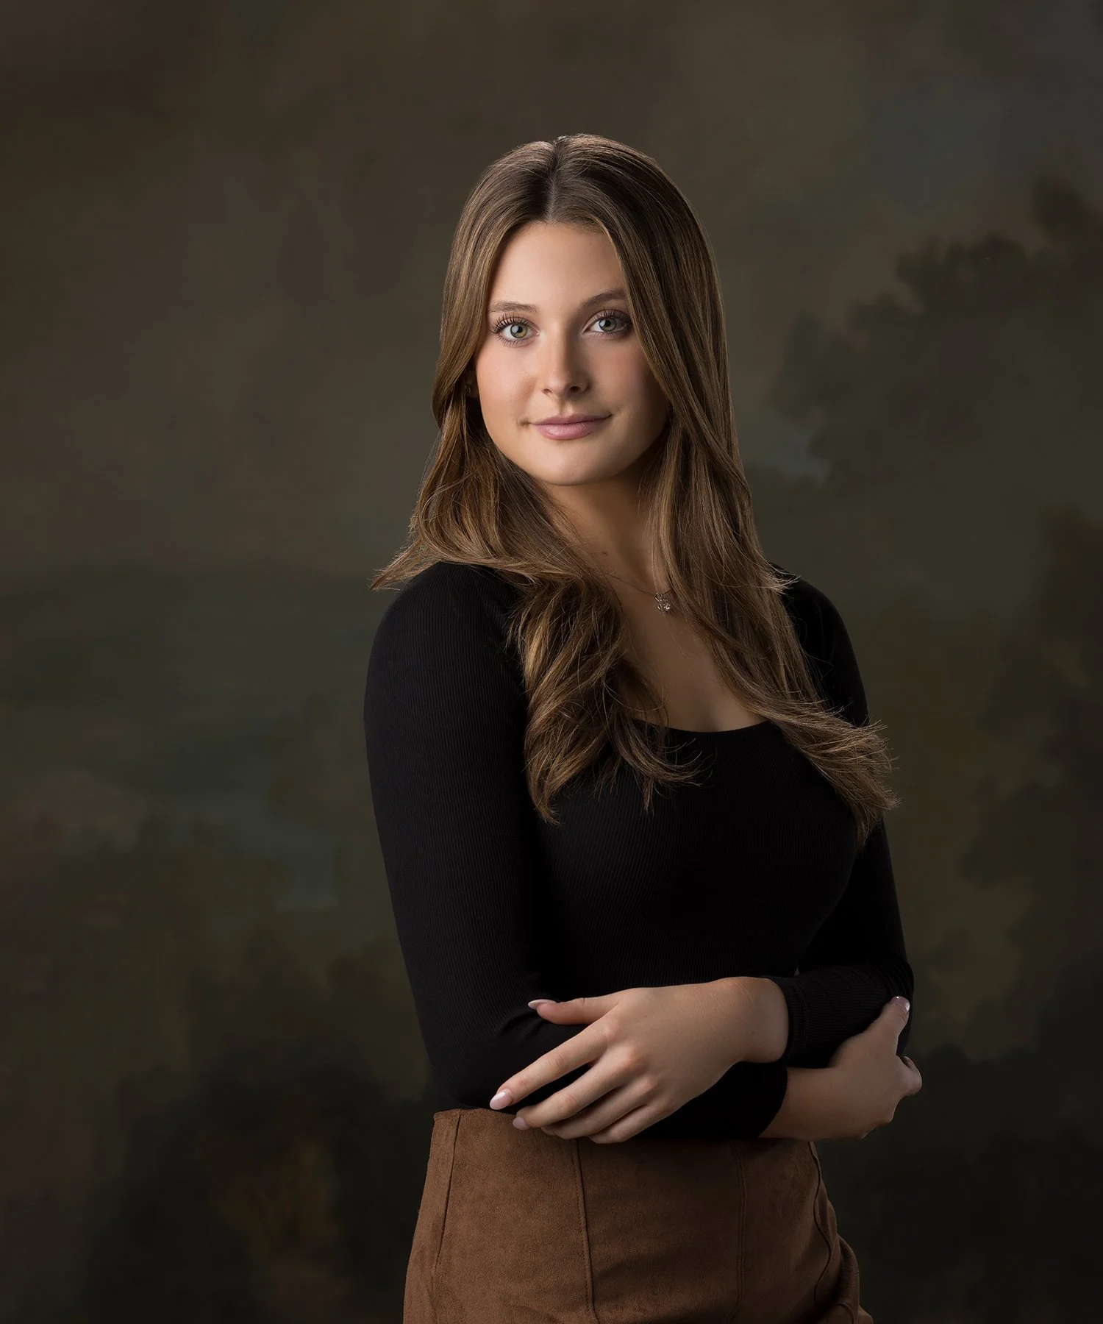

*Reference Input — portrait2.jpg*

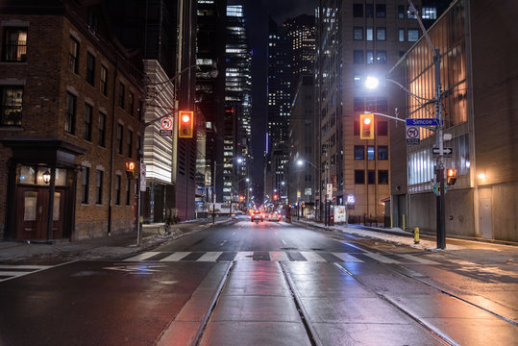

*Reference Input — street.jpg*

# Appendix B — Sidecar JSONs (full content)

File: A_faithful_s1234.json

{  
 "input": "data\\content\\portrait2.jpg",  
 "output": "Extra\\images\\A_faithful_s1234.png",  
 "subject_guess": "portrait",  
 "metrics": {  
 "psnr": 20.198,  
 "ssim": 0.7105,  
 "edge_iou": 0.4613,  
 "colorfulness": 21.96,  
 "entropy": 6.056,  
 "lpips": 0.3951,  
 "arcface_cos": null  
 },  
 "env": {  
 "python": "3.10.11",  
 "platform": "Windows-10-10.0.26100-SP0",  
 "has_torch": true,  
 "has_lpips": true,  
 "has_insightface": false  
 },  
 "notes": "Generated by phase3_eval_advanced.py (images-only path)."  
}

File: A_faithful_s7890.json

{  
 "input": "data\\content\\portrait2.jpg",  
 "output": "Extra\\images\\A_faithful_s7890.png",  
 "subject_guess": "portrait",  
 "metrics": {  
 "psnr": 21.155,  
 "ssim": 0.7433,  
 "edge_iou": 0.5041,  
 "colorfulness": 22.05,  
 "entropy": 6.247,  
 "lpips": 0.3082,  
 "arcface_cos": null  
 },  
 "env": {  
 "python": "3.10.11",  
 "platform": "Windows-10-10.0.26100-SP0",  
 "has_torch": true,  
 "has_lpips": true,  
 "has_insightface": false  
 },  
 "notes": "Generated by phase3_eval_advanced.py (images-only path)."  
}

File: B_stylized_s1234.json

{  
 "input": "data\\content\\portrait2.jpg",  
 "output": "Extra\\images\\B_stylized_s1234.png",  
 "subject_guess": "portrait",  
 "metrics": {  
 "psnr": 17.873,  
 "ssim": 0.6702,  
 "edge_iou": 0.4587,  
 "colorfulness": 27.73,  
 "entropy": 6.255,  
 "lpips": 0.4509,  
 "arcface_cos": null  
 },  
 "env": {  
 "python": "3.10.11",  
 "platform": "Windows-10-10.0.26100-SP0",  
 "has_torch": true,  
 "has_lpips": true,  
 "has_insightface": false  
 },  
 "notes": "Generated by phase3_eval_advanced.py (images-only path)."  
}

File: B_stylized_s7890.json

{  
 "input": "data\\content\\portrait2.jpg",  
 "output": "Extra\\images\\B_stylized_s7890.png",  
 "subject_guess": "portrait",  
 "metrics": {  
 "psnr": 17.974,  
 "ssim": 0.6981,  
 "edge_iou": 0.4986,  
 "colorfulness": 27.24,  
 "entropy": 6.139,  
 "lpips": 0.3708,  
 "arcface_cos": null  
 },  
 "env": {  
 "python": "3.10.11",  
 "platform": "Windows-10-10.0.26100-SP0",  
 "has_torch": true,  
 "has_lpips": true,  
 "has_insightface": false  
 },  
 "notes": "Generated by phase3_eval_advanced.py (images-only path)."  
}

File: out_cinematic_portrait_v5.json

{  
 "input": "data\\content\\portrait2.jpg",  
 "output": "Extra\\images\\out_cinematic_portrait_v5.png",  
 "subject_guess": "portrait",  
 "metrics": {  
 "psnr": 19.836,  
 "ssim": 0.8291,  
 "edge_iou": 0.6962,  
 "colorfulness": 40.27,  
 "entropy": 6.087,  
 "lpips": 0.4498,  
 "arcface_cos": null  
 },  
 "env": {  
 "python": "3.10.11",  
 "platform": "Windows-10-10.0.26100-SP0",  
 "has_torch": true,  
 "has_lpips": true,  
 "has_insightface": false  
 },  
 "notes": "Generated by phase3_eval_advanced.py (images-only path)."  
}

File: out_cinematic_scene_v5.json

{  
 "input": "data\\content\\street.jpg",  
 "output": "Extra\\images\\out_cinematic_scene_v5.png",  
 "subject_guess": "scene",  
 "metrics": {  
 "psnr": 11.56,  
 "ssim": 0.2971,  
 "edge_iou": 0.3106,  
 "colorfulness": 103.73,  
 "entropy": 7.351,  
 "lpips": 0.6322,  
 "arcface_cos": null  
 },  
 "env": {  
 "python": "3.10.11",  
 "platform": "Windows-10-10.0.26100-SP0",  
 "has_torch": true,  
 "has_lpips": true,  
 "has_insightface": false  
 },  
 "notes": "Generated by phase3_eval_advanced.py (images-only path)."  
}

File: out_noir_portrait.json

{  
 "input": "data\\content\\portrait2.jpg",  
 "output": "Extra\\images\\out_noir_portrait.png",  
 "subject_guess": "portrait",  
 "metrics": {  
 "psnr": 25.815,  
 "ssim": 0.8653,  
 "edge_iou": 0.7048,  
 "colorfulness": 1.4,  
 "entropy": 6.211,  
 "lpips": 0.2249,  
 "arcface_cos": null  
 },  
 "env": {  
 "python": "3.10.11",  
 "platform": "Windows-10-10.0.26100-SP0",  
 "has_torch": true,  
 "has_lpips": true,  
 "has_insightface": false  
 },  
 "notes": "Generated by phase3_eval_advanced.py (images-only path)."  
}

File: out_noir_scene.json

{  
 "input": "data\\content\\street.jpg",  
 "output": "Extra\\images\\out_noir_scene.png",  
 "subject_guess": "scene",  
 "metrics": {  
 "psnr": 11.902,  
 "ssim": 0.1464,  
 "edge_iou": 0.2413,  
 "colorfulness": 2.25,  
 "entropy": 7.278,  
 "lpips": 0.5307,  
 "arcface_cos": null  
 },  
 "env": {  
 "python": "3.10.11",  
 "platform": "Windows-10-10.0.26100-SP0",  
 "has_torch": true,  
 "has_lpips": true,  
 "has_insightface": false  
 },  
 "notes": "Generated by phase3_eval_advanced.py (images-only path)."  
}

File: out_portrait_cyberpunk_finalBoost.json

{  
 "input": "data\\content\\portrait2.jpg",  
 "output": "Extra\\images\\out_portrait_cyberpunk_finalBoost.png",  
 "subject_guess": "portrait",  
 "metrics": {  
 "psnr": 19.432,  
 "ssim": 0.7111,  
 "edge_iou": 0.3275,  
 "colorfulness": 36.6,  
 "entropy": 6.507,  
 "lpips": 0.4905,  
 "arcface_cos": null  
 },  
 "env": {  
 "python": "3.10.11",  
 "platform": "Windows-10-10.0.26100-SP0",  
 "has_torch": true,  
 "has_lpips": true,  
 "has_insightface": false  
 },  
 "notes": "Generated by phase3_eval_advanced.py (images-only path)."  
}

File: out_street_cyberpunk_8p5plus.json

{  
 "input": "data\\content\\street.jpg",  
 "output": "Extra\\images\\out_street_cyberpunk_8p5plus.png",  
 "subject_guess": "scene",  
 "metrics": {  
 "psnr": 16.633,  
 "ssim": 0.4069,  
 "edge_iou": 0.3264,  
 "colorfulness": 51.45,  
 "entropy": 7.168,  
 "lpips": 0.4316,  
 "arcface_cos": null  
 },  
 "env": {  
 "python": "3.10.11",  
 "platform": "Windows-10-10.0.26100-SP0",  
 "has_torch": true,  
 "has_lpips": true,  
 "has_insightface": false  
 },  
 "notes": "Generated by phase3_eval_advanced.py (images-only path)."  
}

# Provenance & Runtime (declared from presets)

Parameters below are taken directly from your Phase‑3 preset commands and script names. Fields not captured by presets (base model checkpoint, runtime, VRAM) are left blank so you can fill actual values from your machine.

|  |  |  |  |  |  |  |  |  |  |  |  |  |
| --- | --- | --- | --- | --- | --- | --- | --- | --- | --- | --- | --- | --- |
| Plugin | Variant | Subject | Seeds | Steps | Guidance | Strength | Control (type/scale) | Scheduler | Key knobs | Base model | Runtime (s) | VRAM (GB) |
| anime_stylize_v2.py | A (faithful) | portrait | 1234, 7890 | 34 | 8.0 | 0.65 | auto / 0.85 | — | — |  |  |  |
| anime_stylize_v2.py | B (stylized) | portrait | 1234, 7890 | 32 | 8.5 | 0.70 | auto / 0.85 | — | — |  |  |  |
| cyberpunk_stylize_v3.py | — | portrait | 101 | 44 | 6.2 | 0.21 | depth+softedge / 0.36 | dpmpp | neon 0.40, bloom 0.44; rim 0.42; refine 0.14 |  |  |  |
| cyberpunk_stylize_v3.py | — | scene | 77 | 60 | 6.8 | 0.32 | canny / 0.42 | dpmpp | neon 0.90, bloom 0.80; rim 0.62; scanlines 0.10; refine 0.20 |  |  |  |
| noir_stylize.py | Classic | portrait | 77 | 34 | 6.0 | 0.18 | — | — | halation 0.20, bloom σ1.9, thresh 0.80; vignette 0.12; dither 0.003 |  |  |  |
| noir_stylize.py | Classic | scene | 77 | 42 | 6.8 | 0.74 | canny / 0.62 | — | halation 0.16, bloom σ1.7, thresh 0.88; vignette 0.15; dither 0.0035 |  |  |  |
| cinematic_stylize_v5.py | Obsidian‑Gold | portrait | 77 | 34 | 6.2 | 0.24 | — / 0.30 | — | tone‑mix 0.22, bloom 0.22, contrast 0.18, sat 1.06 |  |  |  |
| cinematic_stylize_v5.py | Obsidian‑Gold | scene | 77 | 36 | 6.6 | 0.40 | — / 0.50 | — | tone‑mix 0.40, bloom 0.42, contrast 0.24, sat 1.06 |  |  |  |